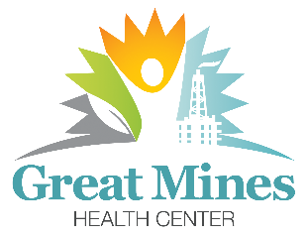

SCHOOL-BASED COUNSELOR (SBHC)
- Licensed Clinical Social Worker (LCSW)
- Licensed Master Social Worker (LMSW)
- Licensed Professional Counselor (LPC)

Job Category: Behavioral Health Services
Schedule: Full-Time
Location: School-Based
Description:

Great Mines Health Center is currently seeking a motivated, mission-oriented School-Based Counselor/Social Worker to complement our current behavioral health staff. The School-Based Counselor/Social Worker provides behavioral health services to local schools commensurate with clinical skills that comply with clinical guidelines, administrative policies/protocols of Great Mines Health Center (GMHC), the State of Missouri, and accrediting/funding agencies.

Required Skills:
- Proven work experience as a clinical social worker or professional counselor
- Working knowledge of social theories and practices
- Social perceptiveness and empathy with a mission to help the underserved
- Ability to build and maintain professional helping relationships
- Ability to relate and communicate with diverse population and groups
- Experience in child counseling
- State license to practice clinical social work and/or professional counseling
- Willing to submit to and pass background check and employment drug screen.

In addition to our general benefits listed on our website, we also assist in continuing education fees, student loan forgiveness opportunities, incentive program, malpractice insurance, and more. A modified schedule may be offered based on school calendar.

